Exercise: API Testing with Postman
This document defines the exercise assignments for the
"QA Back-End Automation" Course @ SoftUni

Create a Trello account
In the upcoming exercise we will use the API provided by Trello. If you don't already have an account in Trello, create one by going to trello.com and then clicking on "Get Trello for Free" button. Don't use your corporate e-mail, because your organization may already have other Atlassian products associated with your email and you may get errors if you try to use Trello.
- After account setup, create a new board named "Learning Postman".
- On the board, create lists titled "To Do" and "Done" to organize tasks.
- Add tasks such as "Sign up for Trello", "Read API documentation", and "Use the Trello API" in the
"To Do" list.
- Move tasks to the "Done" list, once they are completed.

The API will allow us instead of using the trello.com website, to use Postman to interact with it and create boards, lists, tasks, manage and test them.

Trello API Authentication and Authorization
In order to use the Trello API, we need to have an API Key and Token. Trello API doesn't use passwords. In order to have API Key and Token we need to create Trello Power-Up.
Navigate to https://trello.com/power-ups/admin
Agree to the Trello Developer Terms
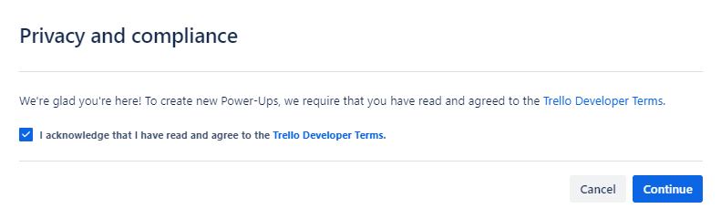
- Create a New App
- Fill in some data. Leave the red one as it is. We named our App "LearningPostman", but feel free to
choose otherwise.

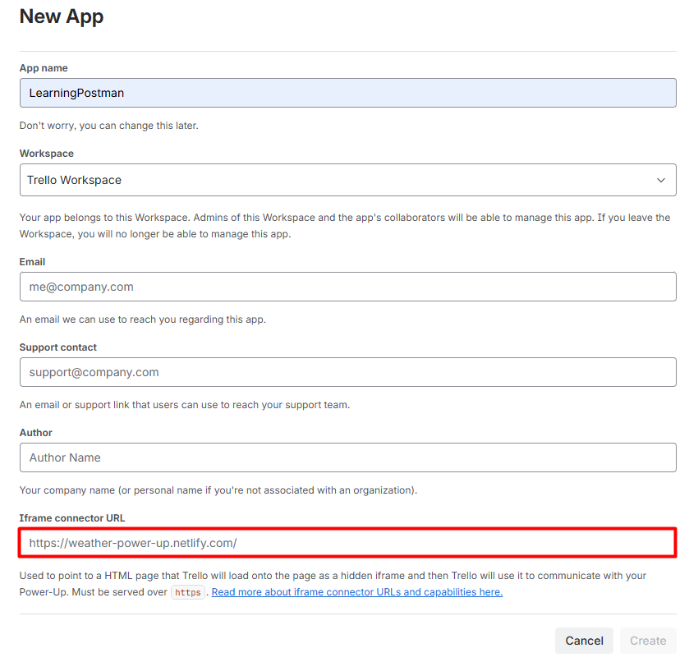

- Click on "Generate a new API Key button"
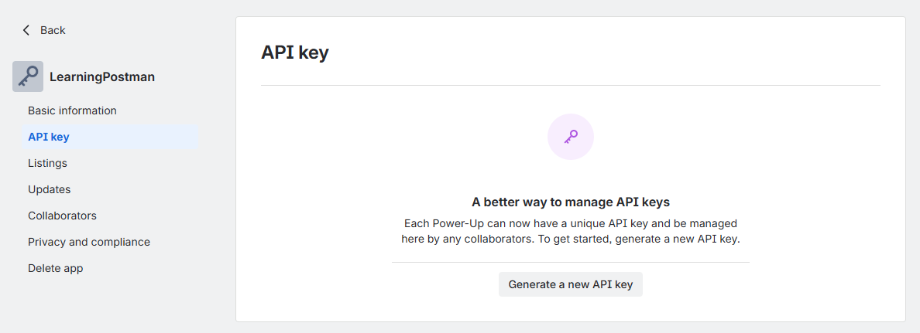

- And then "Generate API key"
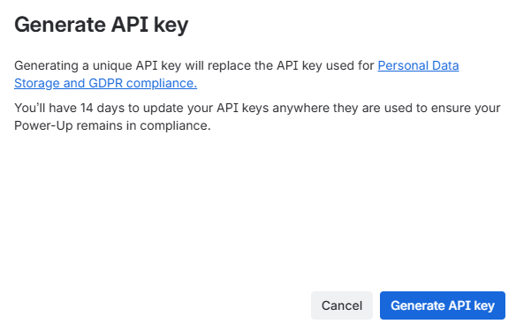

- We need the API key. Forget the other options. Copy and paste your API Key somewhere safe, because we will need it in order to make requests and click on Token.
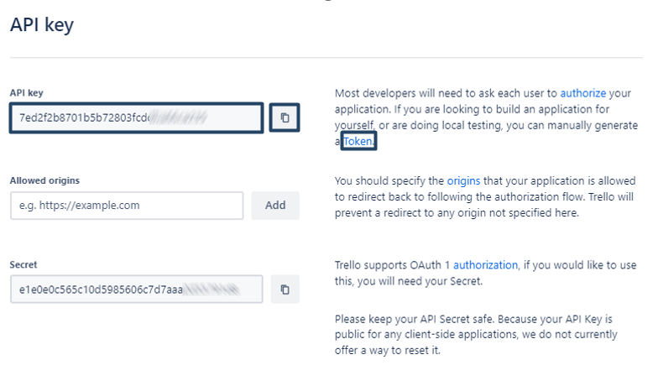
- On the page that will open in a new tab, you have to give permission to your Power-Up (in our case, we named our Power-Up "LearningPostman", remember?) to use your Trello Account.
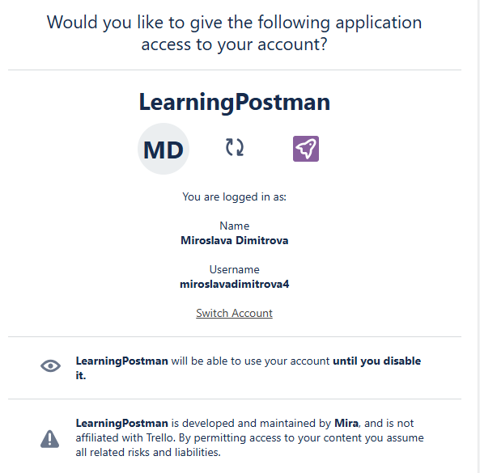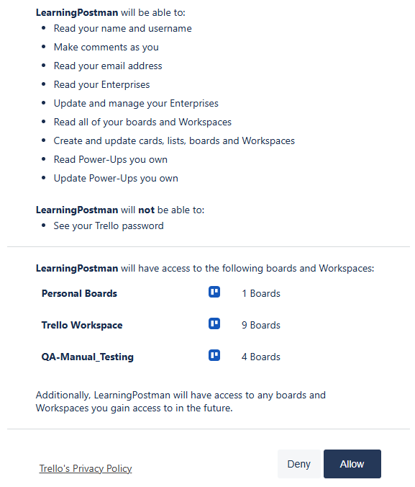

- And it will generate your Token. Copy and paste this Token somewhere safe, because you will need it in your Postman requests.
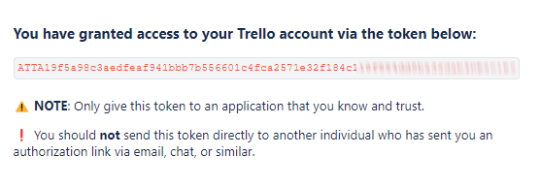

First Request
Now that you have you API Key and your Token, (you can think of your API Key as a username and Token as a password) let's try our first API call. We will get all of the boards from our workspace. Considering you have at least one.
https://api.trello.com/1/members/me/boards?key={yourKey}&token={yourToken}
So, what we see here is the endpoint, which is: https://api.trello.com/1/members/me/boards
And two query parameters – key and token. This is the syntax that this API uses. You need to replace "yourKey" with the value of your API key and "yourToken" with the value of your Token. Remember that these { } are just placeholders, so remove them.
- So, send your first request!
- In the response returned you should see the board that we created via Trello website or any other board that you have in the Trello Workspace.
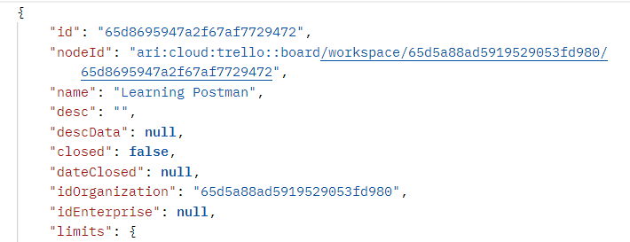

Create a Collection for your Requests
Create a collection for your requests in Postman.
- Give it a proper name. We called ours "Trello API" (not very creative)
- Move the above request in the "Trello API" Collection and rename it to "Get All Boards"

Collection Variables
Since we will use https://api.trello.com in all of our requests, also each request requires authentication (API key and Token), let's turn those into collection variables.
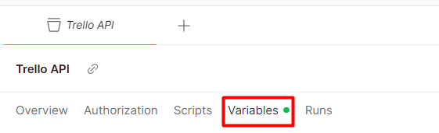
- Add new collection variable {{baseURL}} variable with value https://api.trello.com
- Add new collection variable {{trelloKey}}
- Add new collection variable {{trelloToken}}
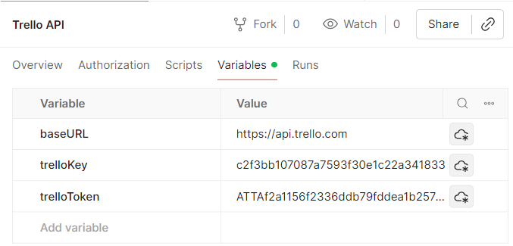

- At the end the URL of "Get All Boards" request should look like this:

Trello API Documentation
Whenever you're trying to use a new API, you need to find and study the API documentation. It will give you an idea about everything you need to know about the API:
https://developer.atlassian.com/cloud/trello/rest/api-group-actions/#api-group-actions

Writing requests
- As you create your requests:
  - Feel free to check Trello's Website to observe what's happening;

- Get all boards
You've already done this one

- Create a new board
You can find the URL and the required parameters here:
https://developer.atlassian.com/cloud/trello/rest/api-group-boards/#api-boards-post
Assert that the response code is 200
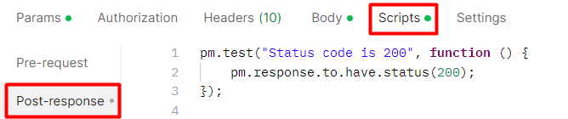
Note: If you ever get the following message as a response, it means that you have exceeded the maximum of boards that you can have and need to close and permanently delete some of them.

- Get a single board
You can find the URL and the required parameters here:
https://developer.atlassian.com/cloud/trello/rest/api-group-boards/#api-boards-id-get
Hint: You can find the id of the board from your "Get All Boards" request
Assert that the response code is 200

- Create a TO DO List on your Board
Note: Since Trello creates three sample lists named 'To Do,' 'Doing,' and 'Done' for each new board, please go to Trello.com and archive these lists to avoid any confusion.

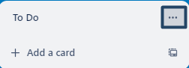
You can find the URL and the required parameters here:
https://developer.atlassian.com/cloud/trello/rest/api-group-boards/#api-boards-id-lists-post
Assert that the response code is 200

- Create a DONE List on your Board
You can find a different way to create a list here:
https://developer.atlassian.com/cloud/trello/rest/api-group-lists/#api-lists-post
Assert that the response code is 200

- Get All Lists from a Board
You can find the URL and the required parameters here:
https://developer.atlassian.com/cloud/trello/rest/api-group-boards/#api-boards-id-lists-get
Assert that the response code is 200

- Create a Card in the TO DO List
Create a "Sign-up for Trello" card in TO DO list
You can find the URL and the required parameters here:
https://developer.atlassian.com/cloud/trello/rest/api-group-cards/#api-cards-post
Assert that the response code is 200
Hint: Get the id of the TO DO list from the previous request.

- Move Card to DONE list
This is done via PUT request:
https://developer.atlassian.com/cloud/trello/rest/api-group-cards/#api-cards-id-put
Hint: Think what query parameter you need to add in order to change the list
Assert that the response code is 200

- Delete the card
You can find the URL and the required parameters here:
https://developer.atlassian.com/cloud/trello/rest/api-group-cards/#api-cards-id-delete
Assert that the response code is 200

- Delete the board
You can find the URL and the required parameters here:
https://developer.atlassian.com/cloud/trello/rest/api-group-boards/#api-boards-id-delete
Assert that the response code is 200
We only have tests asserting the status code is 200, but let's try to run our tests once more one by one. Most of the tests are failing, right? Why is that?

Writing Scripts and Tests
Let's take a closer look at our requests
- Get All Boards
Nothing wrong here. Although, we can add some more tests:
  - Assert that the API response body is not empty
  - Assert that API response time is less than 30 seconds
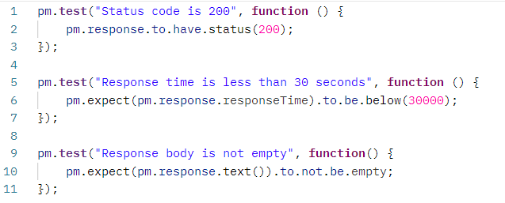

- Create a new board
Nothing wrong here either. Each time we're creating a new board, with the same name (in our case) "Learning Postman", but since we're deleting the board at the last request of the collection, we won't end up with multiple boards with the same name.
  - Assert that the board created has the expected name
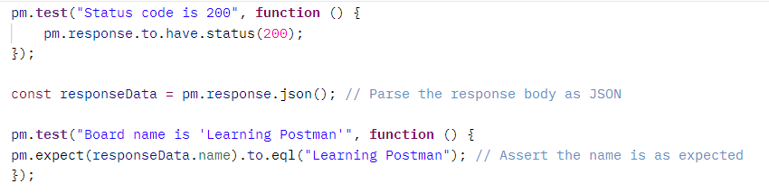

- Get a single board
This test will pass once and then fail each time. Why is that? Each time we're creating a board, no matter its name, the API is giving it a different id. So, when we try to Get the board from the previous request the test will pass just once, because at the end of our collection we are deleting the board and creating a new one with a different id. In order for this test to pass we have to get the id of the board from the previous request each time. How to do that?
- In the Tests tab of the previous request (Create a new board), we parse the response body and extract the board ID, then we set this ID as a collection variable within Postman.
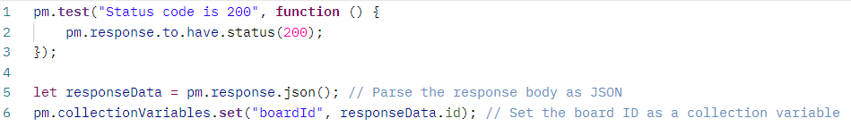
- Then in the current request (Get a single board) use {{boardId}} in the URL as a path variable.
- Assert that the response body has property 'name' of type string and it is equal to 'Learning Postman'
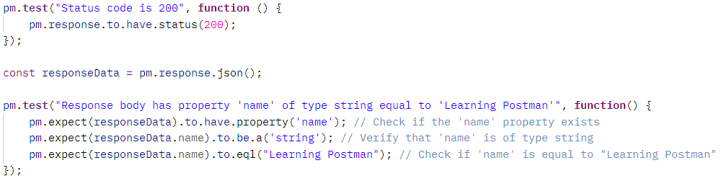

- Create a TO DO List
You should again use {{boardId}} in the URL, but this time as a query parameter.
And let's write some more tests:
  - Assert that the response contains all the expected fields
  - Assert that the 'closed' field is false and is of type Boolean
  - Assert that the idBoard in the response matches the expected board ID
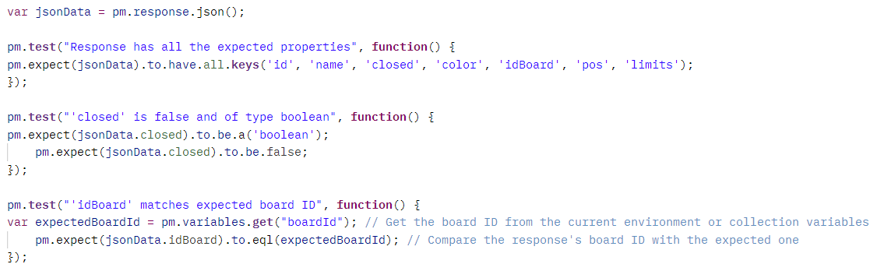

- Create a DONE List
You should again use {{boardId}} in the URL, as a query parameter. But how about this time we are not creating a DONE list, but we create a list with a different name every single time?!
  - In the Pre-Request Tab generate a random number and use it as part of the list name
  - Sets this unique name as a Postman variable named uniqueListName
  - Replace the static list name with the variable {{uniqueListName}} you've just set in the Pre-request Script
Note: You can use Math.random or add the current date and time to create a unique name
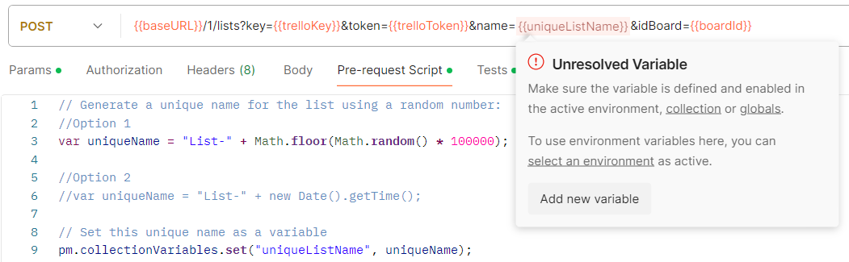
At first {{iniqueListName}} will light as Unresolved Variable, this is because we have to execute the request in order to run the pre-request script and to set the variable.
- Assert that that the list created matches the unique name used in creation
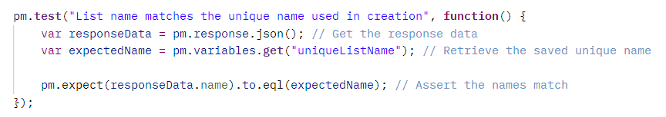
Note: Don't forget to rename the request from "Create a DONE List" to something like "Move Card to List with Unique Name"
- Add the following in the Tests tab as well. Believe me you will need it.
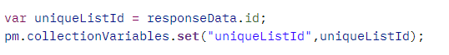

- Get All Lists from a Board
Nothing special here. Just replace the path variable {id} with the {{boardId}} variable
Think what you can assert here?!
- Response is an Array
- Array is not empty
- Presence of a List with a Specific Name
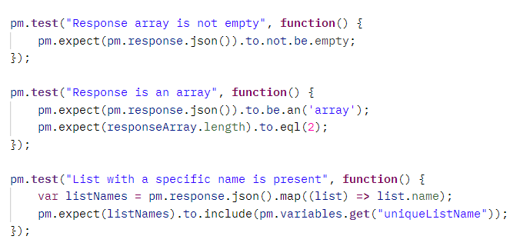
- Create a Card in the TO DO List
So, what do we need here?
First, we need the id of the TO DO list and maybe, if you want to practice creating unique names each time you create a card, you could do that, but it's up to you. We'll not showing it again. You have the information needed in the previous requests. So, we'll create "Sign-up for Trello" card each time.
- So, TO DO list id, we head back to "Create TO DO List" request and add the following script into
the Tests tab:
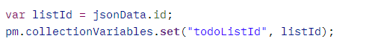
  - Then we use the variable as a query parameter in Create a Card in the TO DO List
- We will need the id of the card in the next two requests, so it is advisable to write a script to get the id.
Since all of the boards, cards, lists have id, be really careful about the names of your variables in order not to duplicate it. Call this one {{cardId}}. The script should be placed in the Tests tab.
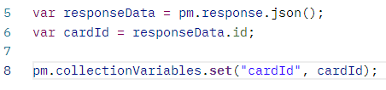
- Write some asserts here. What can you assert? Many things in the response. Be creative!
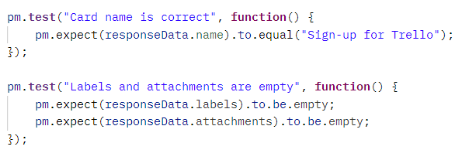

- Move Card to List with Unique Name (ex-DONE list)
You need to replace the {id} with the {{cardId}}. And also replace, the hardcoded value of the query parameter idList. Where can you get this one? You already have it. We took it when we created List with Unique Name
  - Assert that the card is moved
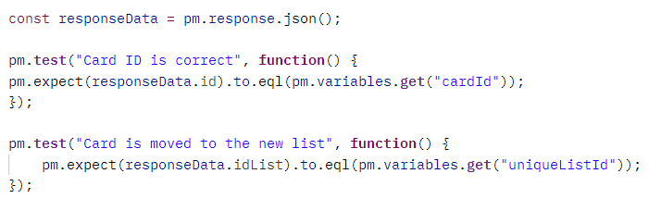
- Delete Card
Same here. Replace the {{id}} with the {{cardId}}
The response here is:
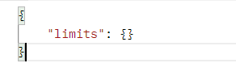
What can you assert?

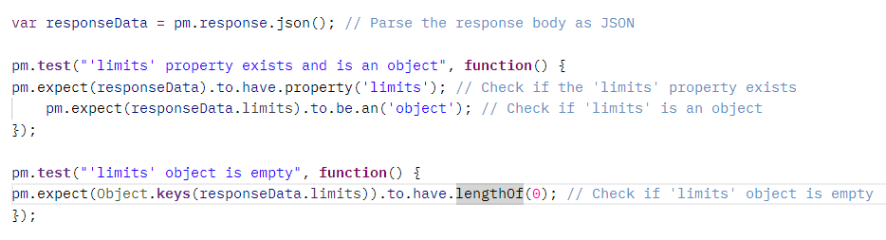

- Delete Board
You need the board id for this one.
The response is:
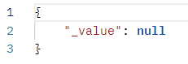
  - Assert that it is null.
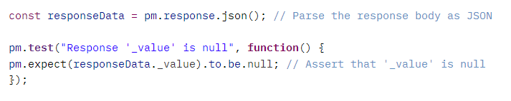

Running all the tests
At this point we advise you to go to your Trello.com board and clear everything that might prevent you from observing the results of each request. Close any boards that may have been left open from the creation of requests and tests.
Run each test one by one. Make sure that each pass. After you've run all the tests, you should see your Trello workspace looking just like it did at the start. This is because our first request creates a board, and our final request deletes that same board.

In the next exercise, we will proceed with automation...

